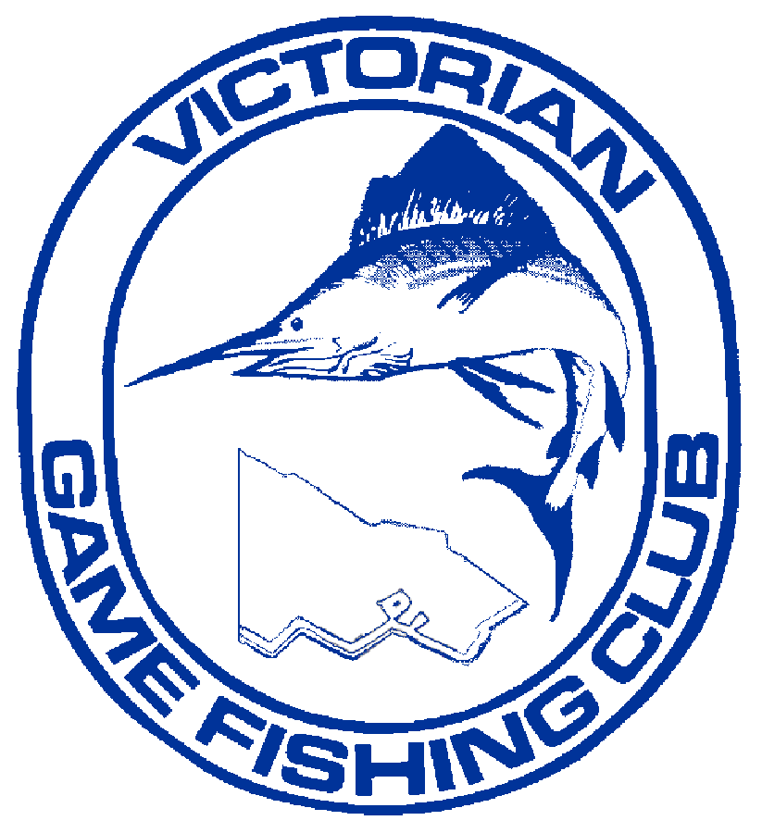

ENTRY FORM

THE VICTORIAN GAME FISHING CLUB
PRESENTS THE….

2023 SIMRAD

VICTORIAN TUNA CLASSIC

AUGUST 19TH – 20th APOLLO BAY, VICTORIA

TEAM INFORMATION

SURNAME | FIRST NAME | Snr Male / Snr Female Junior /Small Fry | CLUB
CAPTAIN
CREW
Only members affiliated with GFAA or overseas visitors affiliated with IGFA can fish this tournament

TOURNAMENT ENTRY FEES

FISHING
Senior Male / Female | No. | at $100* | $
Juniors | No. | at $60* | $
Small Fry | No. | at $60* | $

- Entry to tournament includes a $25 Meal Voucher at Great Ocean Road Brewhouse on the Evening of Saturday 19TH AUGUST.
MUST Present Voucher To Redeem Your Discount.
Captain’s Postal Address
Captain’s Home/Mobile Phone Number
Phone Number During Tournament
Captain’s Address During Tournament

All Team Captains
MUST complete ALL Team Information, including the Safety Checklist and Insurance Details on page 2.
Team Captains can Email completed forms to vgfc18@yahoo.com or present to Registration Desk at the Tournament Briefing.

[To be completed by the Team Captain]

BOAT INFORMATION
Name of Vessel Reg No
Make of Vessel (Including Year) Length
Type: Full Cabin Half Cabin Other
Colour: Hull Topside Canopy
Number of Engines Fuel Type
Make of Engine/s Horsepower
Vehicle Registration Trailer Registration
Radio Equipment: VHF 27MHz
Navigational Equipment: GPS Depth Sounder Radar
On Board Mobile Phone Number 1) 2)
All craft must comply with minimum Victorian safety requirements and must be equipped with the minimum radio channels VHF 16, 72 and 80 or 27MHz Marine 27.88 MHz, 27.94 MHz and 27.96 MHz.

SAFETY CHECKLIST

Bailing Bucket Flares – Parachute
Emergency Rations Flares – 2 Orange Smoke
Fresh Water (2litres per person) Flares – 2 Red Star
Sea Anchor E.P.I.R.B. (406)
Distress V Sheet Reflective Mirror
Paddle (single engine boat)

INSURANCE DETAILS

I certify that my Vessel is insured as follows:
Insured Insurer
Type of Insurance Policy No.
Expiry Date

Signature of Insured Date

My crew and I agree to abide by the rules of the tournament and understand that any clarification requested will be provided by the tournament committee at the tournament briefing. In addition we agree that participation is at own risk and that the holding of this tournament is not to be construed as an invitation to go to sea in conditions beyond the capability of craft and crew.

Signed – Team Captain Date

Team Captain’s Email address

